|  |  |  |  |  |  |
| --- | --- | --- | --- | --- | --- |
| **Group Statistics** | | | | | |
|  | Algorithm | N | Mean | Std. Deviation | Std. Error Mean |
| Accuracy | InceptionV3 | 10 | 97.1940 | .88212 | .27895 |
| Squeeze Net | 10 | 91.7890 | .33782 | .10683 |

|  |  |  |  |  |  |  |  |  |  |  |
| --- | --- | --- | --- | --- | --- | --- | --- | --- | --- | --- |
| **Independent Samples Test** | | | | | | | | | | |
|  | | Levene's Test for Equality of Variances | | t-test for Equality of Means | | | | | | |
| F | Sig. | t | df | Sig. (2-tailed) | Mean Difference | Std. Error Difference | 95% Confidence Interval of the Difference | |
| Lower | Upper |
| Accuracy | Equal variances assumed | 6.310 | .022 | 18.095 | 18 | .000 | 5.40500 | .29871 | 4.77744 | 6.03256 |
| Equal variances not assumed |  |  | 18.095 | 11.584 | .000 | 5.40500 | .29871 | 4.75157 | 6.05843 |

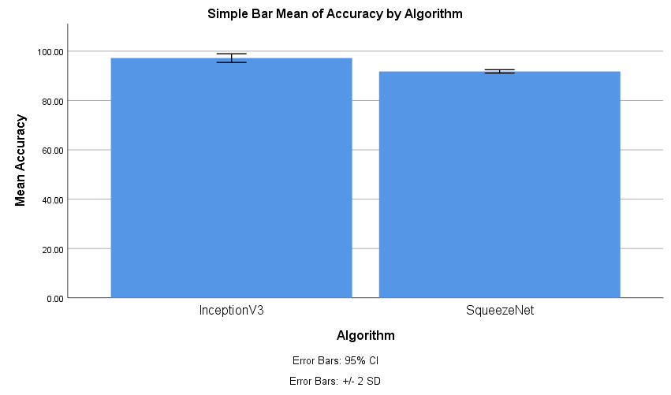

Resnet18 2nd

|  |  |  |  |  |  |
| --- | --- | --- | --- | --- | --- |
| **Group Statistics** | | | | | |
|  | Algorithm | N | Mean | Std. Deviation | Std. Error Mean |
| Accuracy | InceptionV3 | 10 | 97.1940 | .88212 | .27895 |
| ResNet18 | 10 | 92.1350 | .69262 | .21902 |

|  |  |  |  |  |  |  |  |  |  |  |
| --- | --- | --- | --- | --- | --- | --- | --- | --- | --- | --- |
| **Independent Samples Test** | | | | | | | | | | |
|  | | Levene's Test for Equality of Variances | | t-test for Equality of Means | | | | | | |
| F | Sig. | t | df | Sig. (2-tailed) | Mean Difference | Std. Error Difference | 95% Confidence Interval of the Difference | |
| Lower | Upper |
| Accuracy | Equal variances assumed | .181 | .675 | 14.264 | 18 | .000 | 5.05900 | .35466 | 4.31388 | 5.80412 |
| Equal variances not assumed |  |  | 14.264 | 17.041 | .000 | 5.05900 | .35466 | 4.31086 | 5.80714 |

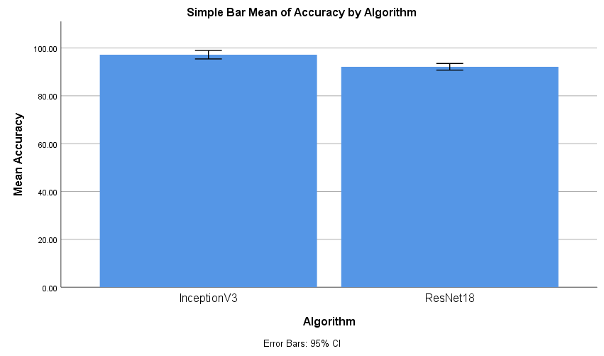

VGG 19 3RD

|  |  |  |  |  |  |
| --- | --- | --- | --- | --- | --- |
| **Group Statistics** | | | | | |
|  | Algorithm | N | Mean | Std. Deviation | Std. Error Mean |
| Accuracy | InceptionV3 | 10 | 97.1940 | .88212 | .27895 |
| VGG19 | 10 | 87.2870 | .52869 | .16719 |

|  |  |  |  |  |  |  |  |  |  |  |
| --- | --- | --- | --- | --- | --- | --- | --- | --- | --- | --- |
| **Independent Samples Test** | | | | | | | | | | |
|  | | Levene's Test for Equality of Variances | | t-test for Equality of Means | | | | | | |
| F | Sig. | t | df | Sig. (2-tailed) | Mean Difference | Std. Error Difference | 95% Confidence Interval of the Difference | |
| Lower | Upper |
| Accuracy | Equal variances assumed | 1.976 | .177 | 30.463 | 18 | .000 | 9.90700 | .32522 | 9.22375 | 10.59025 |
| Equal variances not assumed |  |  | 30.463 | 14.727 | .000 | 9.90700 | .32522 | 9.21270 | 10.60130 |

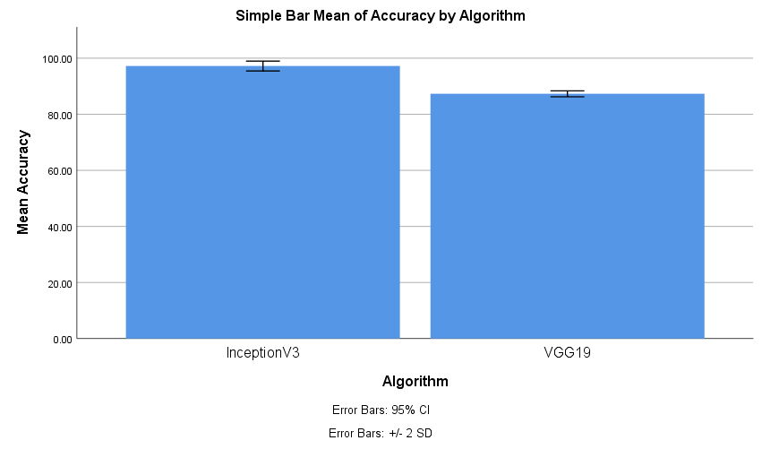

Alexnet 4TH

|  |  |  |  |  |  |
| --- | --- | --- | --- | --- | --- |
| **Group Statistics** | | | | | |
|  | Algorithm | N | Mean | Std. Deviation | Std. Error Mean |
| Accuracy | InceptionV3 | 10 | 97.1940 | .88212 | .27895 |
| AlexNet | 10 | 90.0420 | .38701 | .12238 |

|  |  |  |  |  |  |  |  |  |  |  |
| --- | --- | --- | --- | --- | --- | --- | --- | --- | --- | --- |
| **Independent Samples Test** | | | | | | | | | | |
|  | | Levene's Test for Equality of Variances | | t-test for Equality of Means | | | | | | |
| F | Sig. | t | df | Sig. (2-tailed) | Mean Difference | Std. Error Difference | 95% Confidence Interval of the Difference | |
| Lower | Upper |
| Accuracy | Equal variances assumed | 5.146 | .036 | 23.479 | 18 | .000 | 7.15200 | .30462 | 6.51202 | 7.79198 |
| Equal variances not assumed |  |  | 23.479 | 12.341 | .000 | 7.15200 | .30462 | 6.49033 | 7.81367 |

